**ASSSIGNMENT 3**

|  |  |
| --- | --- |
| **TEAM ID** | **PNT2022TMID49640** |
| **PROJECT NAME** | **NUTRITION ASSISTANT APPLICATION** |
| **NAME** | **J.ANGELIN STAR** |
| **REGISTER NO** | **950019106004** |

**1.Create a Bucket in IBM object storage**

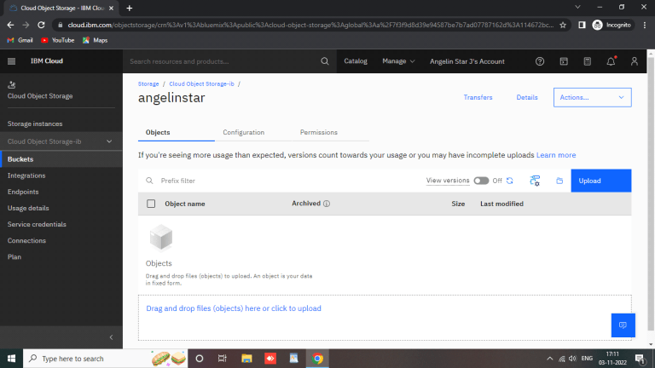

**2.Upload 5 images to ibm object storage and make it public write html code displaying all the 5 images.**

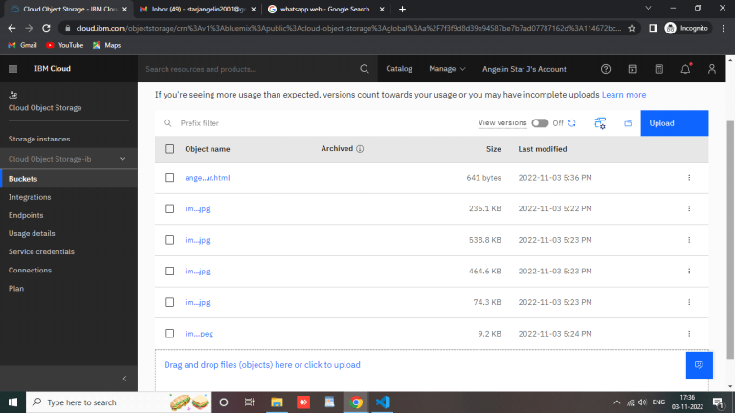

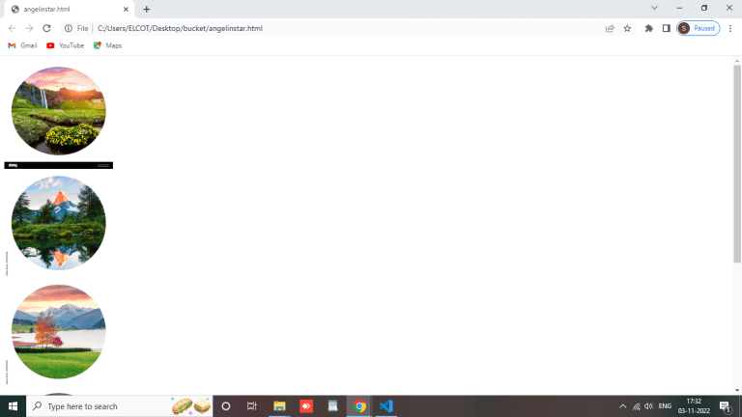

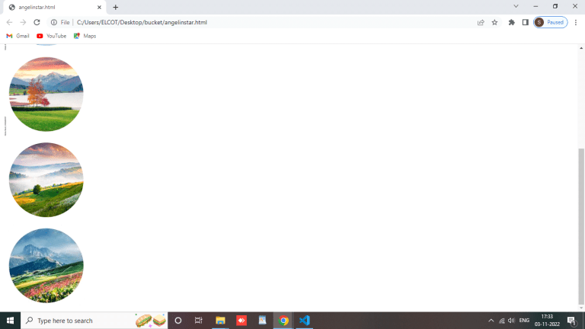

**angelinstar.html**

<html>

<head>

<link rel="stylesheet" href="style.css">

</head>

<div class="row">

<div class="column">

<img src="img1.jpg" alt="Disable" style="width: 200px;height: 200px;">

</div>

<div class="column">

<img src="img2.jpg" alt="Disable" style="width: 200px;height: 200px;">

</div>

<div class="column">

<img src="img3.jpg" alt="Disable" style="width: 200px;height: 200px;"> </div>

<div class="column">

<img src="img4.jpg" alt="Disable" style="width: 200px;height: 200px;">

</div>

<div class="column">

<img src="C:\Users\ELCOT\Desktop\bucket\img5.jpeg" alt="Disable" style="width: 200px;height: 200px;">

</div>

</div>

</html>

**3.Upload a css page to the object storage and use the same page in your HTML code.**

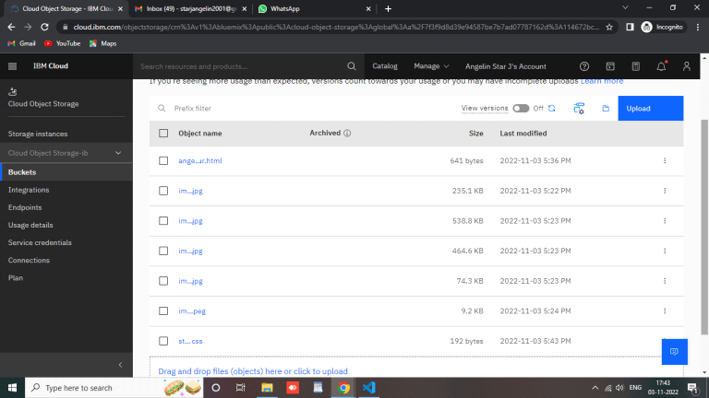

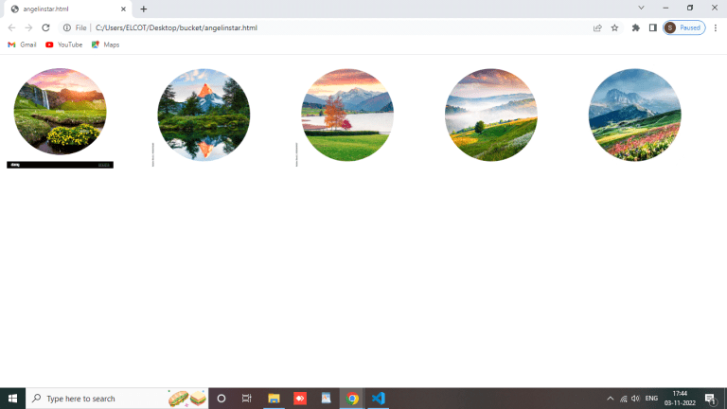

**style.css**

.column {

float: left; width: 33.33%; padding: 5px;

}

.row::after {

content: "";

clear: both;

display: table; }

.row { display:

flex; }.column

{ flex: 33.33%;

padding: 5px;

}

**4.Design a chatbot using IBM Watson assistant for hospitals.Ex: User comes with a query to know the branches for that hospital in your city.Submit the web URL of that chat bot as an assignment.**

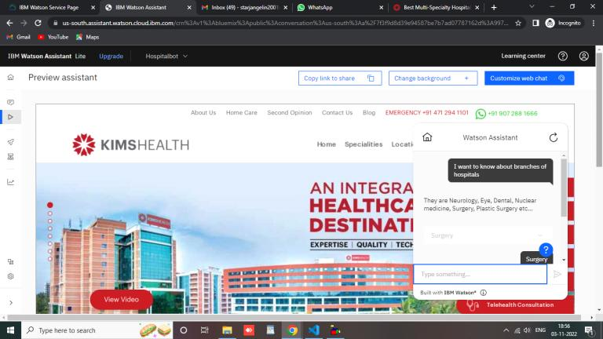

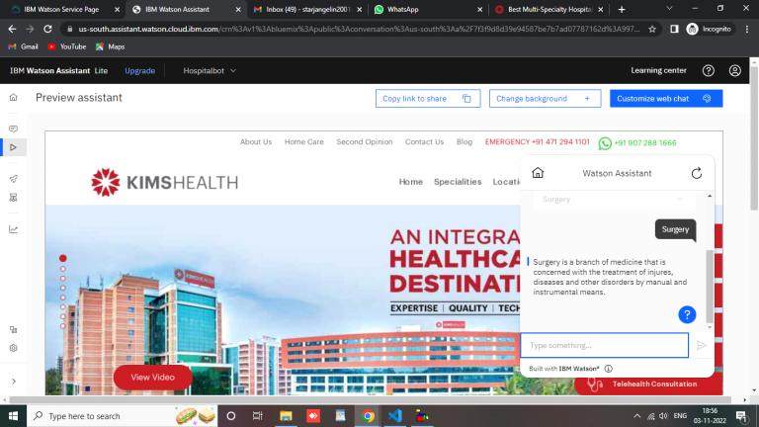

**5.Create a Watson assistant service with 10 steps and use 3 conditions in it.Load that script in the HTML page.**

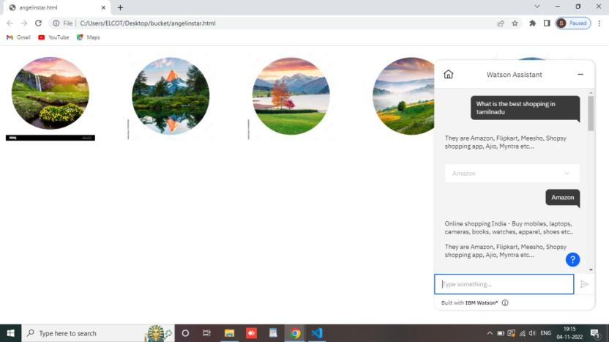

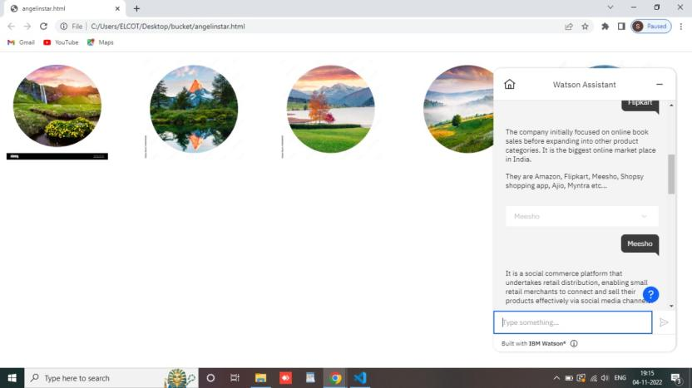

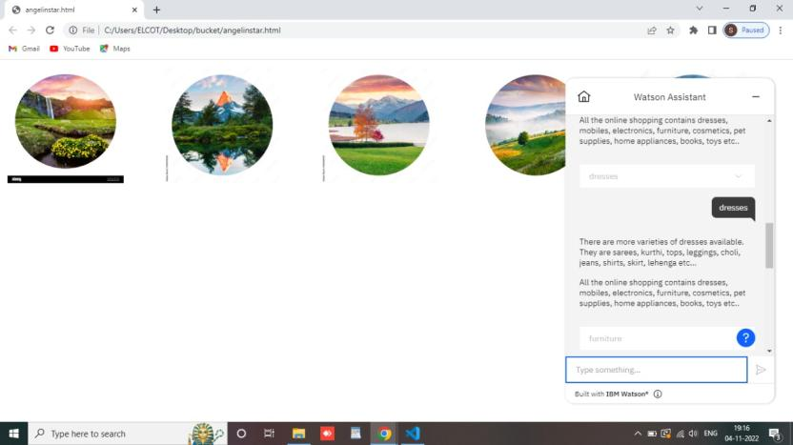

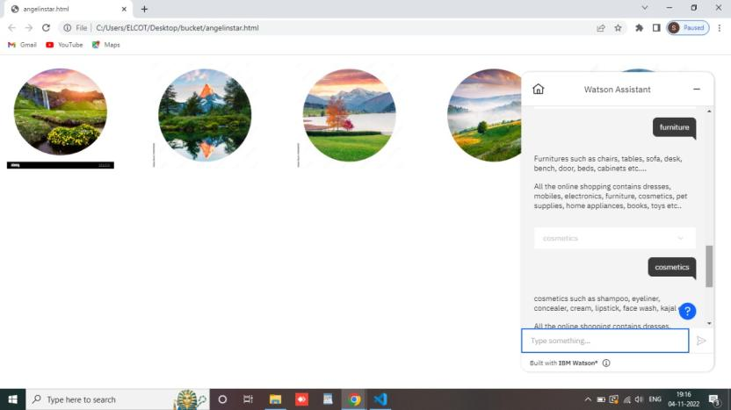

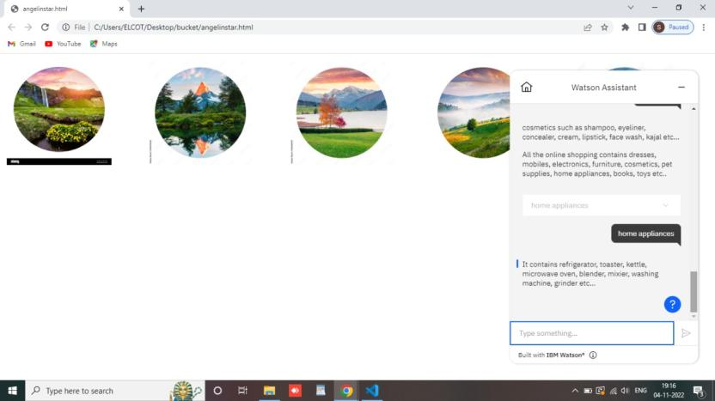

**angelinstar.html**

<html>

<head>

<link rel="stylesheet" href="style.css">

</head>

<div class="row">

<div class="column">

<img src="img1.jpg" alt="Disable" style="width: 200px;height: 200px;">

</div>

<div class="column">

<img src="img2.jpg" alt="Disable" style="width: 200px;height: 200px;">

</div>

<div class="column">

<img src="img3.jpg" alt="Disable" style="width: 200px;height: 200px;"> </div>

<div class="column">

<img src="img4.jpg" alt="Disable" style="width: 200px;height: 200px;">

</div>

<div class="column">

<img src="C:\Users\ELCOT\Desktop\bucket\img5.jpeg" alt="Disable" style="width: 200px;height: 200px;">

</div>

</div>

<script>

window.watsonAssistantChatOptions = {

integrationID: "aabc6a92-0afa-4d57-bded-4bf429b930de", // The ID of this integration.

region: "us-south", // The region your integration is hosted in.

serviceInstanceID: "9973c81b-ade5-4c9c-98a0-f6952ead0134", // The ID of your service instance.

onLoad: function(instance) { instance.render(); }

};

setTimeout(function(){

const t=document.createElement('script');

t.src="https://web-chat.global.assistant.watson.appdomain.cloud/versions/" + (window.watsonAssistantChatOptions.clientVersion || 'latest') + "/WatsonAssistantChatEntry.js";

document.head.appendChild(t);

});

</script>

</html>